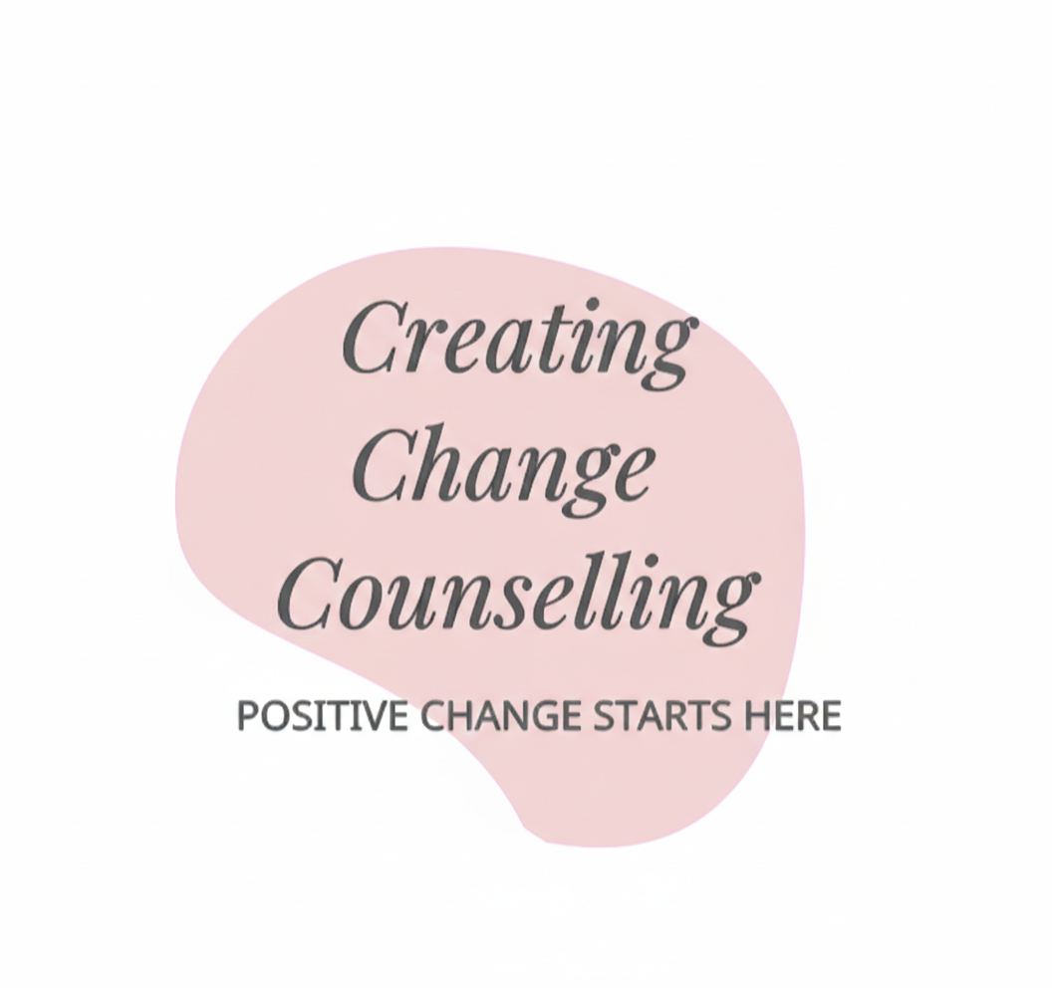
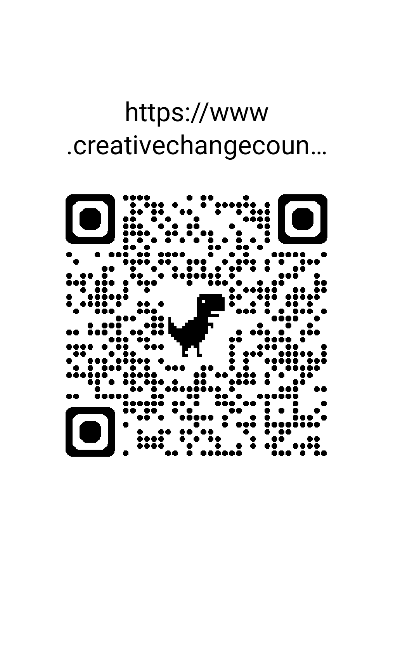My Sensory Cup Worksheet
What fills my cup? (Things that feel like "too much")

• 🔊 Loud noises or many people talking at once.

• 🏷️ Itchy clothes, tags, or tight shoes.

• 💡 Bright lights or flickering screens.

• 🔄 Changes to my routine or unexpected news.

What drains my cup? (Things that help me feel calm)

• 🎧 Wearing my noise-cancelling headphones.

• 💃 Stimming (rocking, spinning, or humming).

• 🕯️ Sitting in a quiet, dimly lit corner.

• 🧸 Holding my favourite fidget or weighted toy.

How do I feel when my cup is full?

• I might feel "fizzy" or shaky inside.

• I might want to hide or go very quiet.

• I might get cross or cry because my brain is too busy.
